Supplementary material

Figure S1 - R0 from deaths for South Africa – (A) Time series of reported cases. (B) The time series presented periods of different growth. We thus fitted the exponential model (see main text) to six time periods. (C) Each period had its own r and thus R, here presented with the Flaxman (blue) and Wallinga methods (red). (D) Aggregating estimations of each of the time periods, we obtained R for the entire period of the reported series. (E-F) We used priors as described in the main text, here presented as a sample of n=1000 for the serial interval used in the Flaxman et al approach (E), and the exponential infectious period (in red) and incubation period (in blue) as well as their resulting serial interval in yellow (F).

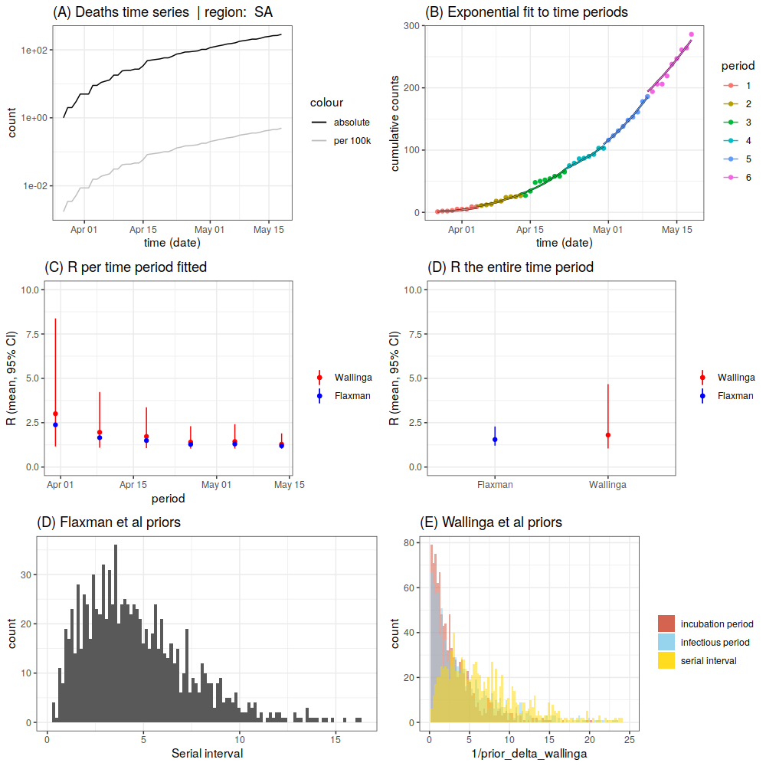

Figure S2 - R0 from cases in South Africa – (A) Time series of death cases. (B-F) Same legend as Figure S1.

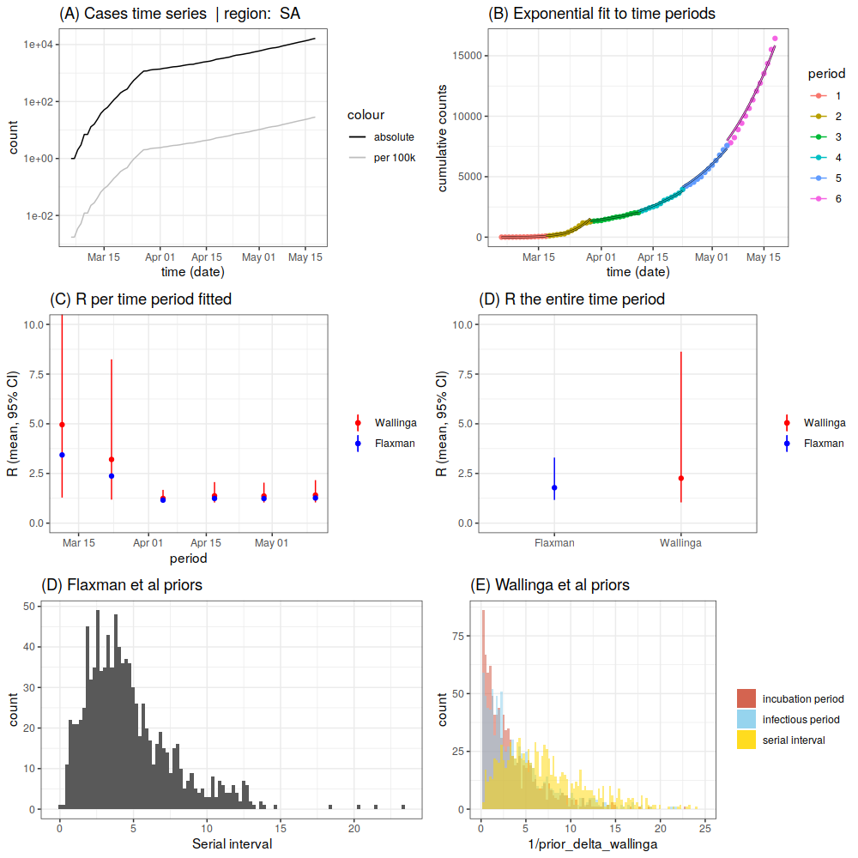

Supplementary Table S1 - Rt from COVID-19 cases from four large provinces in South Africa. WC, Western Cape; EC, Eastern Cape; GP, Gauteng, KZN, KwaZulu-Natal. Low and High 90% interval.

Province | WC |  |  | EC |  |  | GP |  |  | KZN
Date | ML | Low | High | ML | Low | High | ML | Low | High | ML | Low | High
5/18/20 | 1.12 | 0.79 | 1.46 | 1.05 | 0.45 | 1.7 | 0.91 | 0.19 | 1.68 | 1.08 | 0.27 | 1.92
5/19/20 | 1.1 | 0.78 | 1.45 | 1.07 | 0.47 | 1.72 | 0.95 | 0.21 | 1.72 | 1.09 | 0.26 | 1.9
5/20/20 | 1.11 | 0.8 | 1.47 | 1.09 | 0.47 | 1.71 | 0.99 | 0.22 | 1.74 | 1.1 | 0.3 | 1.94
5/21/20 | 1.08 | 0.75 | 1.41 | 1.12 | 0.53 | 1.77 | 1.09 | 0.32 | 1.87 | 1.07 | 0.27 | 1.89
5/22/20 | 1.04 | 0.72 | 1.38 | 1.16 | 0.57 | 1.8 | 1.19 | 0.39 | 1.94 | 1.09 | 0.29 | 1.91

Supplementary Table S2 – Sequencing statistics and demographics for 27 SARS-CoV-2 samples sequenced in this study. Sequences selected, based on initial coverage and sequencing error rates, for whole genome assembly in this study are highlighted in grey.
Sequence Name | Sampling date | Gender | Age | Begin | End | Coverage | Score | Concordance | Matches | Identities | I/D/M/F*
KRISP-002 | 23-Mar-20 | Female | 40 | 280 | 29488 | 82.30 | 49051 | 99.70 | 24602 (99.9%) | 24574 (99.9%) | 2/3
KRISP-003 | 27-Mar-20 | Male | 30 | 321 | 29483 | 40.3 | 23746 | 98.5000 | 99.9 | 99,2 | 3/0
KRISP-004 | 31-Mar-20 | Female | 26 | 221 | 29857 | 83.00 | 49388 | 99.70 | 24801 (99.9%) | 24758 (99.8%) | 0/6
KRISP-005 | 31-Mar-20 | Male | 30 | 30 | 29483 | 56.400 | 32251 | 98.3000 | 98.3 | 97,5 | 6/274
KRISP-006 | 31-Mar-20 | Male | 63 | 41 | 29866 | 97.80 | 58310 | 99.70 | 29241 (99.9%) | 29203 (99.9%) | 1/1
KRISP-007 | 01-Apr-20 | Female | 44 | 7 | 29738 | 97.90 | 58503 | 99.90 | 29287 (99.9%) | 29272 (99.9%) | 0/2
KRISP-008 |  | Female | 43 | N/A
KRISP-009 |  | Female | 64 | 6624 | 28156 | 17.60 | 10435 | 99.10 | 5270 (99.9%) | 5247 (99.5%) | 0/4
KRISP-010 | 01-Apr-20 | Female | 52 | 175 | 29489 | 71.90 | 42018 | 99.40 | 21260 (98.9%) | 21206 (98.7%) | 2/230
KRISP-011 | 01-Apr-20 | Female | 40 | 104 | 29837 | 99.40 | 59434 | 99.90 | 29734 (99.9%) | 29728 (99.9%) | 1/0
KRISP-012 | 01-Apr-20 | Female | 39 | 32 | 29857 | 95.00 | 56635 | 99.70 | 28412 (99.9%) | 28369 (99.8%) | 0/8
KRISP-044 |  | Female | 34 | 669 | 28977 | 19.10 | 11237 | 98.5 | 99.9 | 99.2 | 6/0
KRISP-045 | 27-Mar-20 | Female | 39 | 30 | 29750 | 99.20 | 59212 | 99.9 | 99.9 | 99.9 | 0/8
KRISP-046 |  | Male | 74 | 321 | 29424 | 35.80 | 21211 | 99.3 | 99.9 | 99.6 | 0/12
KRISP-050 |  | Male | 58 | 322 | 29160 | 35.20 | 20879 | 99.4 | 99.9 | 99.6 | 0/8
KRISP-051 | 28-Mar-20 | Female | 55 | 322 | 29866 | 62.20 | 36930 | 99.4 | 99.9 | 99.7 | 0/9
KRISP-052 |  | Male | 70 | 322 | 29493 | 27.70 | 16240 | 98.3 | 99.8 | 99 | 13/1
KRISP-053 |  | U | 60 | 322 | 28951 | 25.50 | 14927 | 98.4 | 99.9 | 99.1 | 0/9
KRISP-101 |  | U | U | 586 | 29756 | 97.000 | 57936 | 99.9000 | 100 | 99,9 | 0/0
KRISP-102 |  | Female | 27 | 32 | 29870 | 99.3 | 59184 | 99.7 | 99.9 | 99,8 | 43831
KRISP-103 |  | Female | 23 | 821 | 29493 | 85.400 | 49598 | 98.9000 | 98.9 | 98,4 | 3/269
KRISP-104 |  | Male | 26 | 321 | 29721 | 75.000 | 44453 | 99.2000 | 99.9 | 99,6 | 43968
KRISP-105 |  | U | U | 17 | 29493 | 84.400 | 50030 | 99.3000 | 99.9 | 99,6 | 43932
KRISP-106 |  | Male | 61 | 104 | 29866 | 99.500 | 59321 | 99.7000 | 99.9 | 99,8 | 0/9
KRISP-107 |  | Male | 44 | 321 | 29864 | 37.900 | 22250 | 98.4000 | 99.9 | 99,1 | 43933
KRISP-108 |  | Female | 45 | 321 | 29691 | 54.100 | 31635 | 98.8000 | 99.3 | 98,7 | 4/108
KRISP-109 |  | Male | 44 | 22 | 29872 | 99.800 | 59519 | 99.7000 | 99.9 | 99,8 | 2/0

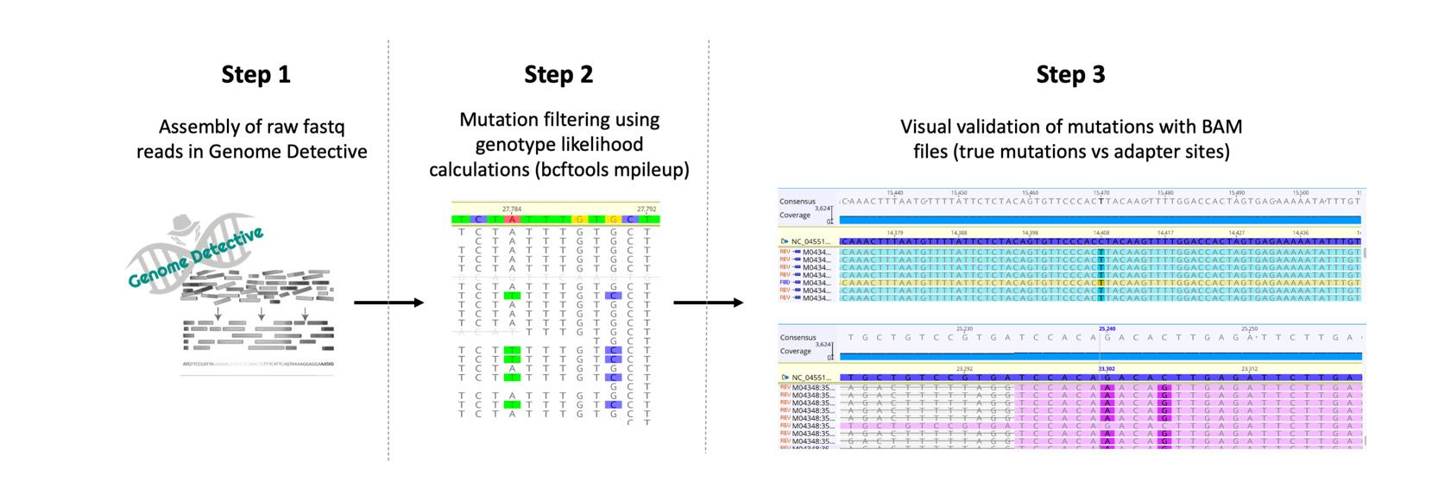
Supplementary Figure S3
Supplementary Figure S1: 3-step workflow for generation of high-quality genomes. Step 1: Raw reads from Illumina and Nanopore sequencing were assembled using the web-based Genome Detective 1.126 (https://www.genomedetective.com/) platform and its coronavirus typing tool; Step 2: The initial assembly obtained from Genome Detective was polished by aligning mapped reads to the references and filtering out mutations with low genotype likelihoods using bcftools 1.7-2 mpileup method. This calculation determines the probability of a genotype at sites containing reads with various bases (e.g. the probability that position 27784 is A vs T in illustration above); Step 3: All mutations were validated visually with BAM files viewed in Geneious software to ensure that called mutations were true and not part of lingering adapter sites.

Supplementary Table S3 – Change in sequencing statistics of 9 genomes generate in this study at 3 steps of the workflow. Final sequencing statistics for each genome highlighted in yellow.

Sequence Name | Workflow Step | Begin | End | Coverage | Score | Concordance | Matches | Identities | I/D/M/F*
KRISP_0002 | 1 | 280 | 29488 | 82.30 | 49051 | 99.70 | 24602 (99.9%) | 24574 (99.9%) | 2/3
 | 2 | 46 | 29700 | 97.50% | 58236 | 99.90% | 29145 (99.9%) | 29134 (99.9%) | 1/0
 | 3 | 56 | 29700 | 97.40% | 58246 | 99.90% | 29135 (100%) | 29129 (99.9%) | 0/0
KRISP_0004 | 1 | 221 | 29857 | 83.00 | 49388 | 99.70 | 24801 (99.9%) | 24758 (99.8%) | 0/6
 | 2 | 46 | 29868 | 99.50% | 59436 | 99.90% | 29756 (99.9%) | 29737 (99.9%) | 1/0
 | 3 | 46 | 29868 | 99.50% | 59466 | 99.90% | 29756 (100%) | 29742 (99.9%) | 0/0
KRISP_0006 | 1 | 41 | 29866 | 97.80 | 58310 | 99.70 | 29241 (99.9%) | 29203 (99.9%) | 1/1
 | 2 | 13 | 29870 | 99.50% | 59456 | 99.90% | 29742 (100%) | 29735 (99.9%) | 0/0
 | 3 | 56 | 29867 | 99.30% | 59376 | 99.90% | 29696 (100%) | 29692 (99.9%) | 0/0
KRISP_0007 | 1 | 7 | 29738 | 97.90 | 58503 | 99.90 | 29287 (99.9%) | 29272 (99.9%) | 0/2
 | 2 | 5 | 29875 | 99.90% | 59694 | 99.90% | 29870 (99.9%) | 29861 (99.9%) | 0/1
 | 3 | 56 | 29867 | 99.70% | 59604 | 99.90% | 29812 (100%) | 29807 (99.9%) | 0/0
KRISP_0010 | 1 | 175 | 29489 | 71.90 | 42018 | 99.40 | 21260 (98.9%) | 21206 (98.7%) | 2/230
 | 2 | 171 | 29678 | 93.40% | 55816 | 99.90% | 27943 (99.9%) | 27928 (99.9%) | 2/0
 | 3 | 171 | 29678 | 93.40% | 55856 | 99.90% | 27943 (100%) | 27933 (99.9%) | 0/0
KRISP_0011 | 1 | 104 | 29837 | 99.40 | 59434 | 99.90 | 29734 (99.9%) | 29728 (99.9%) | 1/0
 | 2 | 1 | 29903 | 100% | 59752 | 99.90% | 29902 (99.9%) | 29894 (99.9%) | 1/1
 | 3 | 56 | 29867 | 99.70% | 59604 | 99.90% | 29812 (100%) | 29807 (99.9%) | 0/0
KRISP_0012 | 1 | 32 | 29857 | 95.00 | 56635 | 99.70 | 28412 (99.9%) | 28369 (99.8%) | 0/8
 | 2 | 4 | 29903 | 99.90% | 59696 | 99.90% | 29872 (100%) | 29860 (99.9%) | 0/0
 | 3 | 56 | 29867 | 99.60% | 59524 | 99.90% | 29784 (100%) | 29773 (99.9%) | 0/0
KRISP_0045 | 1 | 30 | 29750 | 99.20 | 59212 | 99.9 | 99.9 | 99.9 | 0/8
 | 2 | 30 | 29879 | 99.80% | 59648 | 99.90% | 29850 (100%) | 29837 (99.9%) | 0/0
 | 3 | 30 | 29879 | 99.80% | 59652 | 99.90% | 29850 (100%) | 29838 (99.9%) | 0/0
KRISP_0051 | 1 | 322 | 29866 | 62.20 | 36930 | 99.4 | 99.9 | 99.7 | 0/9
 | 2 | 5 | 29868 | 90.10% | 53856 | 99.90% | 26956 (100%) | 26936 (99.9%) | 0/0
 | 3 | 5 | 29868 | 90.40% | 54062 | 99.90% | 27041 (100%) | 27036 (99.9%) | 0/0

Supplementary Table S4 – Mutations called for the SARS-CoV-2 genomes generated in this study

Sequence ID | GISAID ID | Number of mutations | Mutations
KRISP-002 | EPI_ISL_421572 | 6 | 4002C>T, 9223C>T, 11083G>T, 17247T>C, 26144G>T, 27927A>G
KRISP-003 |  | 6 | 241C>T, 1877T>A, 3037C>T, 14408C>T,23404A>G, 24863C>A
KRISP-004 | EPI_ISL_436684 | 9 | 241C>T, 3037C>T, 14408C>T, 18003T>C, 22675C>T, 23403A>G, 28881G>A, 28882G>A, 28883G>C
KRISP-005 |  | 5 | 241C>T, 3037C>T, 14408C>T, 23403A>G, 26063G>T
KRISP-006 | EPI_ISL_421573 | 4 | 6312C>A, 11083G>T, 13730C>T, 28311C>T
KRISP-007 | EPI_ISL_421574 | 5 | 241C>T, 3037C>T, 14408C>T, 16376C>T, 23403A>G
KRISP-010 | EPI_ISL_436685 | 5 | 241C>T, 3037C>T, 14408C>T, 16376C>T, 23403A>G,
KRISP-011 | EPI_ISL_421575 | 5 | 241C>T, 3037C>T, 14408C>T, 16376C>T, 23403A>G
KRISP-012 | EPI_ISL_421576 | 11 | 241C>T, 3037C>T, 5220A>T, 14408C>T, 19170C>T, 19509G>A, 23403A>G, 25461T>C, 28881G>A, 28882G>A, 28883G>C
KRISP-045 | EPI_ISL_436686 | 12 | 241C>T, 3037C>T, 4002C>T, 10097G>A, 11083G>T, 13536C>T, 14408C>T, 23403A>G, 23731C>T, 28881G>A, 28882G>A, 28883G>C
KRISP-051 | EPI_ISL_436687 | 5 | 241C>T, 3037C>T, 14408C>T, 20161A>T, 23403A>G
KRISP-101 |  | 5 | 241C>T, 3037C>T, 8409T>C, 14408C>T, 23403A>G
KRISP-102 |  | 8 | 241C>T, 3037C>T, 14408C>T, 23403A>G, 26004C>T, 28881G>A, 28882G>A, 28883G>C
KRISP-103 |  | 8 | 241C>T, 3037C>T, 5672C>A, 10592A>G, 14408C>T, 16376C>T, 23403A>G, 26063G>T
KRISP-104 |  | 8 | 241C>T, 3037C>T, 5672C>A, 10592A>G, 14408C>T, 16376C>T, 23403A>G, 26063G>T
KRISP-105 |  | 8 | 241C>T, 3037C>T, 13766A>T, 14408C>T, 16376C>T, 18411T>C, 23403A>G, 24034C>T
KRISP-106 |  | 6 | 241C>T, 3037C>T, 14408C>T, 16376C>T, 23403A>G, 24034C>T
KRISP-107 |  | 11 | 241C>T, 3037C>T, 10950A>G, 14408C>T, 23191C>T, 23403A>G, 26884A>C, 26885C>A, 28881G>A, 28882G>A, 28883G>C
KRISP-108 |  | 8 | 241C>T, 2364T>G, 3037C>T, 9086G>A, 14408C>T, 22800G>A, 23403A>G, 27171A>C
KRISP-109 |  | 10 | 241C>T, 3037C>T, 8449A>C, 13115C>T, 14408C>T, 20234C>T, 23403A>G, 28881G>A, 28882G>A, 28883G>C

Supplementary Table S5 – Results from lineage assignment of all KZN sequences in this study using Phylogenetic Assignment of named Global Outbreak LINeages (PANGOLIN) software

taxon | lineage | SH-alrt | UFbootstrap | lineages_version | status
KRISP-002 | B.2 | 100 | 100 | 27/04/2020 | passed_qc
KRISP-003 | B.1 | 100 | 99 | 07/05/2020 | passed_qc
KRISP-004 | B.1 | 100 | 100 | 27/04/2020 | passed_qc
KRISP-005 | B.1 | 100 | 96 | 07/05/2020 | passed_qc
KRISP-006 | B | 100 | 100 | 27/04/2020 | passed_qc
KRISP-007 | B.1 | 100 | 100 | 27/04/2020 | passed_qc
KRISP-010 | B.1 | 100 | 100 | 27/04/2020 | passed_qc
KRISP-011 | B.1 | 100 | 100 | 27/04/2020 | passed_qc
KRISP-012 | B.1.10 | 92 | 87 | 27/04/2020 | passed_qc
KRISP-045 | B.1.1 | 100 | 100 | 27/04/2020 | passed_qc
KRISP-051 | B.1 | 100 | 100 | 27/04/2020 | passed_qc
KRISP-101 | B.1 | 100 | 99 | 07/05/2020 | passed_qc
KRISP-102 | B.1 | 100 | 100 | 07/05/2020 | passed_qc
KRISP-103 | B.1 | 100 | 95 | 07/05/2020 | passed_qc
KRISP-104 | B.1 | 100 | 97 | 07/05/2020 | passed_qc
KRISP-105 | B.1 | 100 | 96 | 07/05/2020 | passed_qc
KRISP-106 | B.1 | 100 | 96 | 07/05/2020 | passed_qc
KRISP-107 | B.1 | 100 | 100 | 07/05/2020 | passed_qc
KRISP-108 | B.1 | 100 | 95 | 07/05/2020 | passed_qc
KRISP-109 | B.1 | 100 | 100 | 07/05/2020 | passed_qc
NICD-R03006 | B.1 | 100 | 99 | 27/04/2020 | passed_qc

Supplementary Figure S5

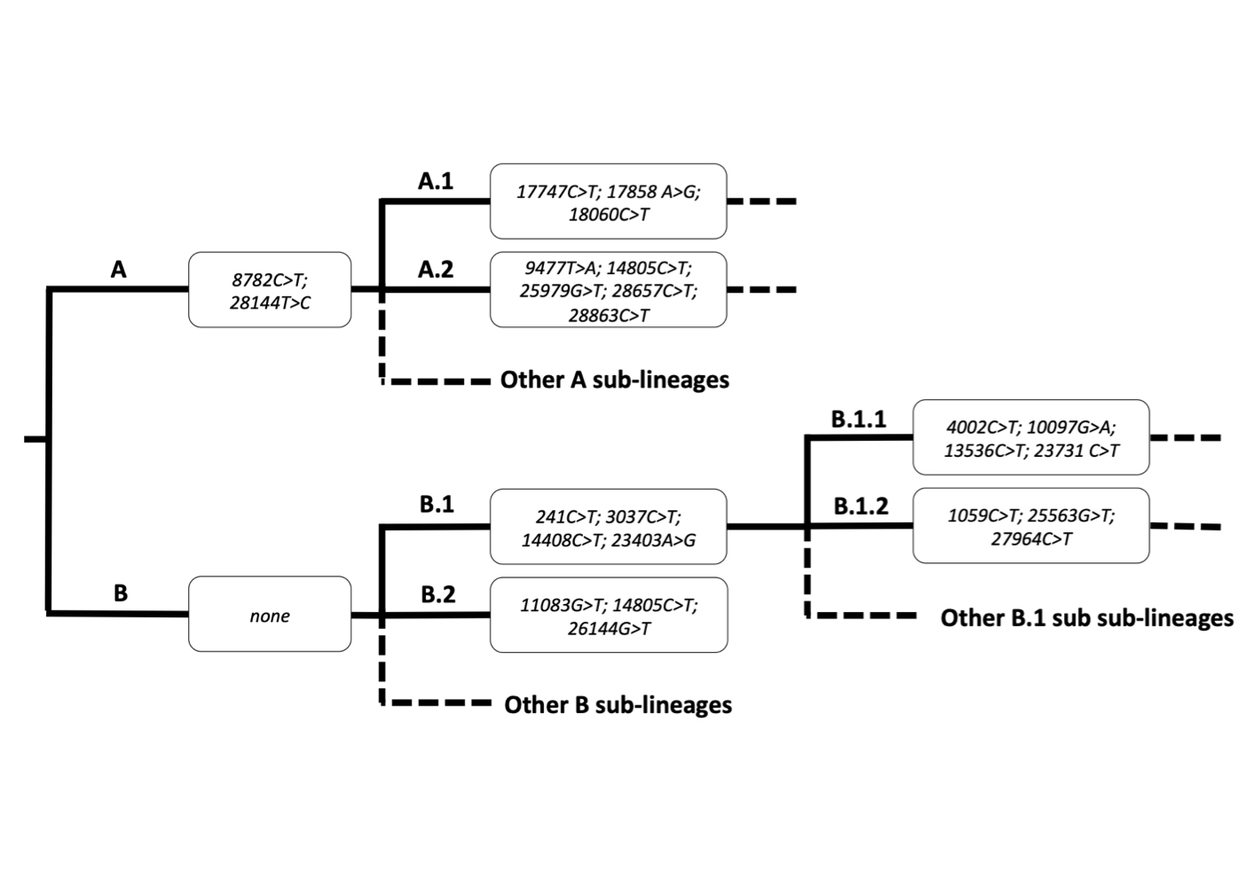
Supplementary Figure S3: Common mutations that appear in the main lineages and sub-lineages of SARS-CoV-2 identified by multiple sequence alignment of subsets of reference sequences.

Supplementary Figure S6

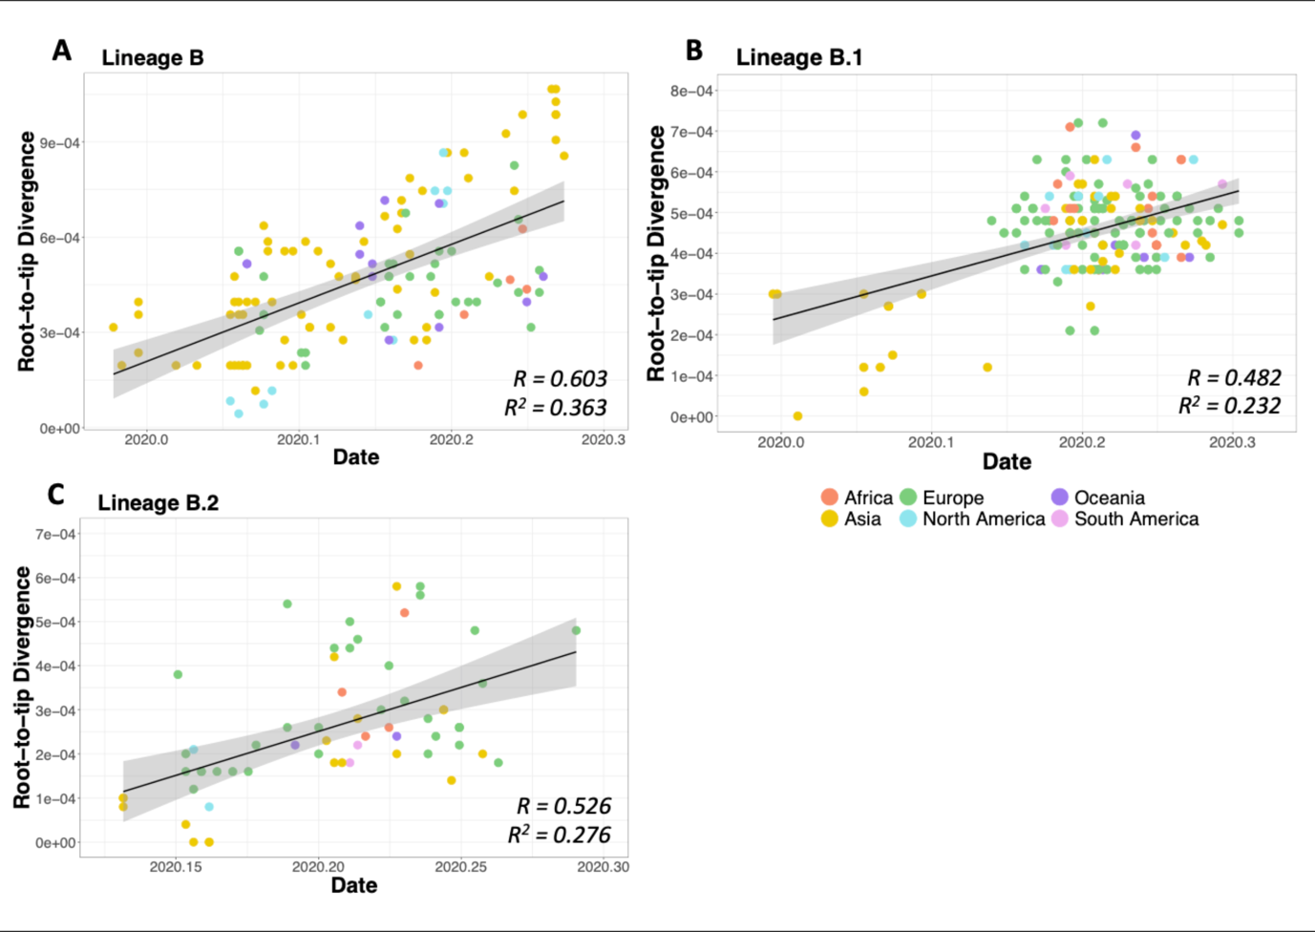
Supplementary Figure S2: TempEst Regression plots. Regression plots comparing genetic divergence from root to tip of inferred phylogenies versus sampling time. Two main lineages A (n=148) and B (n=131) and two sub-lineages B.1 (n=171) and B.2 (n=69) of SARS-CoV-2 were analyzed. Shown are results for lineages B, B.1 and B.2. Coefficients of correlation (R) and coefficients of determination (R2) are indicated at the bottom right hand corner of each plot.

Supplementary Table S6 – PCR Primer Table

Name | Pool | Sequence | Length | %GC | Tm (use 65)
nCoV-2019_1_LEFT | nCoV-2019_1 | ACCAACCAACTTTCGATCTCTTGT | 24 | 41.67 | 60.69
nCoV-2019_1_RIGHT | nCoV-2019_1 | CATCTTTAAGATGTTGACGTGCCTC | 25 | 44.00 | 60.45
nCoV-2019_2_LEFT | nCoV-2019_2 | CTGTTTTACAGGTTCGCGACGT | 22 | 50.00 | 61.67
nCoV-2019_2_RIGHT | nCoV-2019_2 | TAAGGATCAGTGCCAAGCTCGT | 22 | 50.00 | 61.74
nCoV-2019_3_LEFT | nCoV-2019_1 | CGGTAATAAAGGAGCTGGTGGC | 22 | 54.55 | 61.32
nCoV-2019_3_RIGHT | nCoV-2019_1 | AAGGTGTCTGCAATTCATAGCTCT | 24 | 41.67 | 60.32
nCoV-2019_4_LEFT | nCoV-2019_2 | GGTGTATACTGCTGCCGTGAAC | 22 | 54.55 | 61.56
nCoV-2019_4_RIGHT | nCoV-2019_2 | CACAAGTAGTGGCACCTTCTTTAGT | 25 | 44.00 | 60.97
nCoV-2019_5_LEFT | nCoV-2019_1 | TGGTGAAACTTCATGGCAGACG | 22 | 50.00 | 61.39
nCoV-2019_5_RIGHT | nCoV-2019_1 | ATTGATGTTGACTTTCTCTTTTTGGAGT | 28 | 32.14 | 60.17
nCoV-2019_6_LEFT | nCoV-2019_2 | GGTGTTGTTGGAGAAGGTTCCG | 22 | 54.55 | 61.64
nCoV-2019_6_RIGHT | nCoV-2019_2 | TAGCGGCCTTCTGTAAAACACG | 22 | 50.00 | 61.18
nCoV-2019_7_LEFT | nCoV-2019_1 | ATCAGAGGCTGCTCGTGTTGTA | 22 | 50.00 | 61.73
nCoV-2019_7_RIGHT | nCoV-2019_1 | TGCACAGGTGACAATTTGTCCA | 22 | 45.45 | 60.95
nCoV-2019_8_LEFT | nCoV-2019_2 | AGAGTTTCTTAGAGACGGTTGGGA | 24 | 45.83 | 61.00
nCoV-2019_8_RIGHT | nCoV-2019_2 | GCTTCAACAGCTTCACTAGTAGGT | 24 | 45.83 | 60.56
nCoV-2019_9_LEFT | nCoV-2019_1 | TCCCACAGAAGTGTTAACAGAGGA | 24 | 45.83 | 61.18
nCoV-2019_9_RIGHT | nCoV-2019_1 | ATGACAGCATCTGCCACAACAC | 22 | 50.00 | 61.71
nCoV-2019_10_LEFT | nCoV-2019_2 | TGAGAAGTGCTCTGCCTATACAGT | 24 | 45.83 | 61.12
nCoV-2019_10_RIGHT | nCoV-2019_2 | TCATCTAACCAATCTTCTTCTTGCTCT | 27 | 37.04 | 60.31
nCoV-2019_11_LEFT | nCoV-2019_1 | GGAATTTGGTGCCACTTCTGCT | 22 | 50.00 | 61.66
nCoV-2019_11_RIGHT | nCoV-2019_1 | TCATCAGATTCAACTTGCATGGCA | 24 | 41.67 | 61.35
nCoV-2019_12_LEFT | nCoV-2019_2 | AAACATGGAGGAGGTGTTGCAG | 22 | 50.00 | 61.08
nCoV-2019_12_RIGHT | nCoV-2019_2 | TTCACTCTTCATTTCCAAAAAGCTTGA | 27 | 33.33 | 60.36
nCoV-2019_13_LEFT | nCoV-2019_1 | TCGCACAAATGTCTACTTAGCTGT | 24 | 41.67 | 60.56
nCoV-2019_13_RIGHT | nCoV-2019_1 | ACCACAGCAGTTAAAACACCCT | 22 | 45.45 | 60.36
nCoV-2019_14_LEFT | nCoV-2019_2 | CATCCAGATTCTGCCACTCTTGT | 23 | 47.83 | 60.62
nCoV-2019_14_RIGHT | nCoV-2019_2 | AGTTTCCACACAGACAGGCATT | 22 | 45.45 | 60.42
nCoV-2019_15_LEFT | nCoV-2019_1 | ACAGTGCTTAAAAAGTGTAAAAGTGCC | 27 | 37.04 | 61.32
nCoV-2019_15_RIGHT | nCoV-2019_1 | AACAGAAACTGTAGCTGGCACT | 22 | 45.45 | 60.16
nCoV-2019_16_LEFT | nCoV-2019_2 | AATTTGGAAGAAGCTGCTCGGT | 22 | 45.45 | 60.82
nCoV-2019_16_RIGHT | nCoV-2019_2 | CACAACTTGCGTGTGGAGGTTA | 22 | 50.00 | 61.32
nCoV-2019_17_LEFT | nCoV-2019_1 | CTTCTTTCTTTGAGAGAAGTGAGGACT | 27 | 40.74 | 60.69
nCoV-2019_17_RIGHT | nCoV-2019_1 | TTTGTTGGAGTGTTAACAATGCAGT | 25 | 36.00 | 60.11
nCoV-2019_18_LEFT | nCoV-2019_2 | TGGAAATACCCACAAGTTAATGGTTTAAC | 29 | 34.48 | 60.69
nCoV-2019_18_RIGHT | nCoV-2019_2 | AGCTTGTTTACCACACGTACAAGG | 24 | 45.83 | 61.51
nCoV-2019_19_LEFT | nCoV-2019_1 | GCTGTTATGTACATGGGCACACT | 23 | 47.83 | 61.18
nCoV-2019_19_RIGHT | nCoV-2019_1 | TGTCCAACTTAGGGTCAATTTCTGT | 25 | 40.00 | 60.40
nCoV-2019_20_LEFT | nCoV-2019_2 | ACAAAGAAAACAGTTACACAACAACCA | 27 | 33.33 | 60.68
nCoV-2019_20_RIGHT | nCoV-2019_2 | ACGTGGCTTTATTAGTTGCATTGTT | 25 | 36.00 | 60.28
nCoV-2019_21_LEFT | nCoV-2019_1 | TGGCTATTGATTATAAACACTACACACCC | 29 | 37.93 | 61.49
nCoV-2019_21_RIGHT | nCoV-2019_1 | TAGATCTGTGTGGCCAACCTCT | 22 | 50.00 | 60.83
nCoV-2019_22_LEFT | nCoV-2019_2 | ACTACCGAAGTTGTAGGAGACATTATACT | 29 | 37.93 | 61.25
nCoV-2019_22_RIGHT | nCoV-2019_2 | ACAGTATTCTTTGCTATAGTAGTCGGC | 27 | 40.74 | 60.73
nCoV-2019_23_LEFT | nCoV-2019_1 | ACAACTACTAACATAGTTACACGGTGT | 27 | 37.04 | 60.26
nCoV-2019_23_RIGHT | nCoV-2019_1 | ACCAGTACAGTAGGTTGCAATAGTG | 25 | 44.00 | 60.57
nCoV-2019_24_LEFT | nCoV-2019_2 | AGGCATGCCTTCTTACTGTACTG | 23 | 47.83 | 60.37
nCoV-2019_24_RIGHT | nCoV-2019_2 | ACATTCTAACCATAGCTGAAATCGGG | 26 | 42.31 | 61.19
nCoV-2019_25_LEFT | nCoV-2019_1 | GCAATTGTTTTTCAGCTATTTTGCAGT | 27 | 33.33 | 60.73
nCoV-2019_25_RIGHT | nCoV-2019_1 | ACTGTAGTGACAAGTCTCTCGCA | 23 | 47.83 | 61.30
nCoV-2019_26_LEFT | nCoV-2019_2 | TTGTGATACATTCTGTGCTGGTAGT | 25 | 40.00 | 60.28
nCoV-2019_26_RIGHT | nCoV-2019_2 | TCCGCACTATCACCAACATCAG | 22 | 50.00 | 60.42
nCoV-2019_27_LEFT | nCoV-2019_1 | ACTACAGTCAGCTTATGTGTCAACC | 25 | 44.00 | 60.80
nCoV-2019_27_RIGHT | nCoV-2019_1 | AATACAAGCACCAAGGTCACGG | 22 | 50.00 | 61.13
nCoV-2019_28_LEFT | nCoV-2019_2 | ACATAGAAGTTACTGGCGATAGTTGT | 26 | 38.46 | 60.13
nCoV-2019_28_RIGHT | nCoV-2019_2 | TGTTTAGACATGACATGAACAGGTGT | 26 | 38.46 | 60.91
nCoV-2019_29_LEFT | nCoV-2019_1 | ACTTGTGTTCCTTTTTGTTGCTGC | 24 | 41.67 | 61.39
nCoV-2019_29_RIGHT | nCoV-2019_1 | AGTGTACTCTATAAGTTTTGATGGTGTGT | 29 | 34.48 | 60.69
nCoV-2019_30_LEFT | nCoV-2019_2 | GCACAACTAATGGTGACTTTTTGCA | 25 | 40.00 | 61.19
nCoV-2019_30_RIGHT | nCoV-2019_2 | ACCACTAGTAGATACACAAACACCAG | 26 | 42.31 | 60.30
nCoV-2019_31_LEFT | nCoV-2019_1 | TTCTGAGTACTGTAGGCACGGC | 22 | 54.55 | 62.03
nCoV-2019_31_RIGHT | nCoV-2019_1 | ACAGAATAAACACCAGGTAAGAATGAGT | 28 | 35.71 | 60.69
nCoV-2019_32_LEFT | nCoV-2019_2 | TGGTGAATACAGTCATGTAGTTGCC | 25 | 44.00 | 61.09
nCoV-2019_32_RIGHT | nCoV-2019_2 | AGCACATCACTACGCAACTTTAGA | 24 | 41.67 | 60.56
nCoV-2019_33_LEFT | nCoV-2019_1 | ACTTTTGAAGAAGCTGCGCTGT | 22 | 45.45 | 61.58
nCoV-2019_33_RIGHT | nCoV-2019_1 | TGGACAGTAAACTACGTCATCAAGC | 25 | 44.00 | 61.08
nCoV-2019_34_LEFT | nCoV-2019_2 | TCCCATCTGGTAAAGTTGAGGGT | 23 | 47.83 | 61.02
nCoV-2019_34_RIGHT | nCoV-2019_2 | AGTGAAATTGGGCCTCATAGCA | 22 | 45.45 | 60.03
nCoV-2019_35_LEFT | nCoV-2019_1 | TGTTCGCATTCAACCAGGACAG | 22 | 50.00 | 61.39
nCoV-2019_35_RIGHT | nCoV-2019_1 | ACTTCATAGCCACAAGGTTAAAGTCA | 26 | 38.46 | 60.69
nCoV-2019_36_LEFT | nCoV-2019_2 | TTAGCTTGGTTGTACGCTGCTG | 22 | 50.00 | 61.44
nCoV-2019_36_RIGHT | nCoV-2019_2 | GAACAAAGACCATTGAGTACTCTGGA | 26 | 42.31 | 60.74
nCoV-2019_37_LEFT | nCoV-2019_1 | ACACACCACTGGTTGTTACTCAC | 23 | 47.83 | 60.93
nCoV-2019_37_RIGHT | nCoV-2019_1 | GTCCACACTCTCCTAGCACCAT | 22 | 54.55 | 61.48
nCoV-2019_38_LEFT | nCoV-2019_2 | ACTGTGTTATGTATGCATCAGCTGT | 25 | 40.00 | 60.86
nCoV-2019_38_RIGHT | nCoV-2019_2 | CACCAAGAGTCAGTCTAAAGTAGCG | 25 | 48.00 | 61.13
nCoV-2019_39_LEFT | nCoV-2019_1 | AGTATTGCCCTATTTTCTTCATAACTGGT | 29 | 34.48 | 61.00
nCoV-2019_39_RIGHT | nCoV-2019_1 | TGTAACTGGACACATTGAGCCC | 22 | 50.00 | 60.55
nCoV-2019_40_LEFT | nCoV-2019_2 | TGCACATCAGTAGTCTTACTCTCAGT | 26 | 42.31 | 61.25
nCoV-2019_40_RIGHT | nCoV-2019_2 | CATGGCTGCATCACGGTCAAAT | 22 | 50.00 | 62.09
nCoV-2019_41_LEFT | nCoV-2019_1 | GTTCCCTTCCATCATATGCAGCT | 23 | 47.83 | 60.75
nCoV-2019_41_RIGHT | nCoV-2019_1 | TGGTATGACAACCATTAGTTTGGCT | 25 | 40.00 | 60.75
nCoV-2019_42_LEFT | nCoV-2019_2 | TGCAAGAGATGGTTGTGTTCCC | 22 | 50.00 | 61.08
nCoV-2019_42_RIGHT | nCoV-2019_2 | CCTACCTCCCTTTGTTGTGTTGT | 23 | 47.83 | 60.69
nCoV-2019_43_LEFT | nCoV-2019_1 | TACGACAGATGTCTTGTGCTGC | 22 | 50.00 | 60.93
nCoV-2019_43_RIGHT | nCoV-2019_1 | AGCAGCATCTACAGCAAAAGCA | 22 | 45.45 | 61.14
nCoV-2019_44_LEFT | nCoV-2019_2 | TGCCACAGTACGTCTACAAGCT | 22 | 50.00 | 61.66
nCoV-2019_44_RIGHT | nCoV-2019_2 | AACCTTTCCACATACCGCAGAC | 22 | 50.00 | 60.87
nCoV-2019_45_LEFT | nCoV-2019_1 | TACCTACAACTTGTGCTAATGACCC | 25 | 44.00 | 60.57
nCoV-2019_45_RIGHT | nCoV-2019_1 | AAATTGTTTCTTCATGTTGGTAGTTAGAGA | 30 | 30.00 | 60.01
nCoV-2019_46_LEFT | nCoV-2019_2 | TGTCGCTTCCAAGAAAAGGACG | 22 | 50.00 | 61.38
nCoV-2019_46_RIGHT | nCoV-2019_2 | CACGTTCACCTAAGTTGGCGTA | 22 | 50.00 | 60.86
nCoV-2019_47_LEFT | nCoV-2019_1 | AGGACTGGTATGATTTTGTAGAAAACCC | 28 | 39.29 | 61.42
nCoV-2019_47_RIGHT | nCoV-2019_1 | AATAACGGTCAAAGAGTTTTAACCTCTC | 28 | 35.71 | 60.06
nCoV-2019_48_LEFT | nCoV-2019_2 | TGTTGACACTGACTTAACAAAGCCT | 25 | 40.00 | 61.09
nCoV-2019_48_RIGHT | nCoV-2019_2 | TAGATTACCAGAAGCAGCGTGC | 22 | 50.00 | 60.74
nCoV-2019_49_LEFT | nCoV-2019_1 | AGGAATTACTTGTGTATGCTGCTGA | 25 | 40.00 | 60.57
nCoV-2019_49_RIGHT | nCoV-2019_1 | TGACGATGACTTGGTTAGCATTAATACA | 28 | 35.71 | 61.05
nCoV-2019_50_LEFT | nCoV-2019_2 | GTTGATAAGTACTTTGATTGTTACGATGGT | 30 | 33.33 | 60.59
nCoV-2019_50_RIGHT | nCoV-2019_2 | TAACATGTTGTGCCAACCACCA | 22 | 45.45 | 60.95
nCoV-2019_51_LEFT | nCoV-2019_1 | TCAATAGCCGCCACTAGAGGAG | 22 | 54.55 | 61.34
nCoV-2019_51_RIGHT | nCoV-2019_1 | AGTGCATTAACATTGGCCGTGA | 22 | 45.45 | 61.14
nCoV-2019_52_LEFT | nCoV-2019_2 | CATCAGGAGATGCCACAACTGC | 22 | 54.55 | 61.83
nCoV-2019_52_RIGHT | nCoV-2019_2 | GTTGAGAGCAAAATTCATGAGGTCC | 25 | 44.00 | 60.62
nCoV-2019_53_LEFT | nCoV-2019_1 | AGCAAAATGTTGGACTGAGACTGA | 24 | 41.67 | 60.69
nCoV-2019_53_RIGHT | nCoV-2019_1 | AGCCTCATAAAACTCAGGTTCCC | 23 | 47.83 | 60.31
nCoV-2019_54_LEFT | nCoV-2019_2 | TGAGTTAACAGGACACATGTTAGACA | 26 | 38.46 | 60.18
nCoV-2019_54_RIGHT | nCoV-2019_2 | AACCAAAAACTTGTCCATTAGCACA | 25 | 36.00 | 60.11
nCoV-2019_55_LEFT | nCoV-2019_1 | ACTCAACTTTACTTAGGAGGTATGAGCT | 28 | 39.29 | 61.43
nCoV-2019_55_RIGHT | nCoV-2019_1 | GGTGTACTCTCCTATTTGTACTTTACTGT | 29 | 37.93 | 60.54
nCoV-2019_56_LEFT | nCoV-2019_2 | ACCTAGACCACCACTTAACCGA | 22 | 50.00 | 60.49
nCoV-2019_56_RIGHT | nCoV-2019_2 | ACACTATGCGAGCAGAAGGGTA | 22 | 50.00 | 61.21
nCoV-2019_57_LEFT | nCoV-2019_1 | ATTCTACACTCCAGGGACCACC | 22 | 54.55 | 61.16
nCoV-2019_57_RIGHT | nCoV-2019_1 | GTAATTGAGCAGGGTCGCCAAT | 22 | 50.00 | 61.26
nCoV-2019_58_LEFT | nCoV-2019_2 | TGATTTGAGTGTTGTCAATGCCAGA | 25 | 40.00 | 61.44
nCoV-2019_58_RIGHT | nCoV-2019_2 | CTTTTCTCCAAGCAGGGTTACGT | 23 | 47.83 | 61.06
nCoV-2019_59_LEFT | nCoV-2019_1 | TCACGCATGATGTTTCATCTGCA | 23 | 43.48 | 61.42
nCoV-2019_59_RIGHT | nCoV-2019_1 | AAGAGTCCTGTTACATTTTCAGCTTG | 26 | 38.46 | 60.02
nCoV-2019_60_LEFT | nCoV-2019_2 | TGATAGAGACCTTTATGACAAGTTGCA | 27 | 37.04 | 60.53
nCoV-2019_60_RIGHT | nCoV-2019_2 | GGTACCAACAGCTTCTCTAGTAGC | 24 | 50.00 | 60.44
nCoV-2019_61_LEFT | nCoV-2019_1 | TGTTTATCACCCGCGAAGAAGC | 22 | 50.00 | 61.50
nCoV-2019_61_RIGHT | nCoV-2019_1 | ATCACATAGACAACAGGTGCGC | 22 | 50.00 | 61.25
nCoV-2019_62_LEFT | nCoV-2019_2 | GGCACATGGCTTTGAGTTGACA | 22 | 50.00 | 61.91
nCoV-2019_62_RIGHT | nCoV-2019_2 | GTTGAACCTTTCTACAAGCCGC | 22 | 50.00 | 60.35
nCoV-2019_63_LEFT | nCoV-2019_1 | TGTTAAGCGTGTTGACTGGACT | 22 | 45.45 | 60.16
nCoV-2019_63_RIGHT | nCoV-2019_1 | ACAAACTGCCACCATCACAACC | 22 | 50.00 | 61.85
nCoV-2019_64_LEFT | nCoV-2019_2 | TCGATAGATATCCTGCTAATTCCATTGT | 28 | 35.71 | 60.11
nCoV-2019_64_RIGHT | nCoV-2019_2 | AGTCTTGTAAAAGTGTTCCAGAGGT | 25 | 40.00 | 60.10
nCoV-2019_65_LEFT | nCoV-2019_1 | GCTGGCTTTAGCTTGTGGGTTT | 22 | 50.00 | 61.92
nCoV-2019_65_RIGHT | nCoV-2019_1 | TGTCAGTCATAGAACAAACACCAATAGT | 28 | 35.71 | 60.90
nCoV-2019_66_LEFT | nCoV-2019_2 | GGGTGTGGACATTGCTGCTAAT | 22 | 50.00 | 61.21
nCoV-2019_66_RIGHT | nCoV-2019_2 | TCAATTTCCATTTGACTCCTGGGT | 24 | 41.67 | 60.45
nCoV-2019_67_LEFT | nCoV-2019_1 | GTTGTCCAACAATTACCTGAAACTTACT | 28 | 35.71 | 60.43
nCoV-2019_67_RIGHT | nCoV-2019_1 | CAACCTTAGAAACTACAGATAAATCTTGGG | 30 | 36.67 | 60.40
nCoV-2019_68_LEFT | nCoV-2019_2 | ACAGGTTCATCTAAGTGTGTGTGT | 24 | 41.67 | 60.14
nCoV-2019_68_RIGHT | nCoV-2019_2 | CTCCTTTATCAGAACCAGCACCA | 23 | 47.83 | 60.31
nCoV-2019_69_LEFT | nCoV-2019_1 | TGTCGCAAAATATACTCAACTGTGTCA | 27 | 37.04 | 61.43
nCoV-2019_69_RIGHT | nCoV-2019_1 | TCTTTATAGCCACGGAACCTCCA | 23 | 47.83 | 61.14
nCoV-2019_70_LEFT | nCoV-2019_2 | ACAAAAGAAAATGACTCTAAAGAGGGTTT | 29 | 31.03 | 60.13
nCoV-2019_70_RIGHT | nCoV-2019_2 | TGACCTTCTTTTAAAGACATAACAGCAG | 28 | 35.71 | 60.27
nCoV-2019_71_LEFT | nCoV-2019_1 | ACAAATCCAATTCAGTTGTCTTCCTATTC | 29 | 34.48 | 60.54
nCoV-2019_71_RIGHT | nCoV-2019_1 | TGGAAAAGAAAGGTAAGAACAAGTCCT | 27 | 37.04 | 60.80
nCoV-2019_72_LEFT | nCoV-2019_2 | ACACGTGGTGTTTATTACCCTGAC | 24 | 45.83 | 61.04
nCoV-2019_72_RIGHT | nCoV-2019_2 | ACTCTGAACTCACTTTCCATCCAAC | 25 | 44.00 | 60.97
nCoV-2019_73_LEFT | nCoV-2019_1 | CAATTTTGTAATGATCCATTTTTGGGTGT | 29 | 31.03 | 60.29
nCoV-2019_73_RIGHT | nCoV-2019_1 | CACCAGCTGTCCAACCTGAAGA | 22 | 54.55 | 62.45
nCoV-2019_74_LEFT | nCoV-2019_2 | ACATCACTAGGTTTCAAACTTTACTTGC | 28 | 35.71 | 60.68
nCoV-2019_74_RIGHT | nCoV-2019_2 | GCAACACAGTTGCTGATTCTCTTC | 24 | 45.83 | 60.85
nCoV-2019_75_LEFT | nCoV-2019_1 | AGAGTCCAACCAACAGAATCTATTGT | 26 | 38.46 | 60.24
nCoV-2019_75_RIGHT | nCoV-2019_1 | ACCACCAACCTTAGAATCAAGATTGT | 26 | 38.46 | 60.69
nCoV-2019_76_LEFT | nCoV-2019_2 | AGGGCAAACTGGAAAGATTGCT | 22 | 45.45 | 60.76
nCoV-2019_76_RIGHT | nCoV-2019_2 | ACACCTGTGCCTGTTAAACCAT | 22 | 45.45 | 60.42
nCoV-2019_77_LEFT | nCoV-2019_1 | CCAGCAACTGTTTGTGGACCTA | 22 | 50.00 | 60.75
nCoV-2019_77_RIGHT | nCoV-2019_1 | CAGCCCCTATTAAACAGCCTGC | 22 | 54.55 | 61.59
nCoV-2019_78_LEFT | nCoV-2019_2 | CAACTTACTCCTACTTGGCGTGT | 23 | 47.83 | 60.55
nCoV-2019_78_RIGHT | nCoV-2019_2 | TGTGTACAAAAACTGCCATATTGCA | 25 | 36.00 | 60.22
nCoV-2019_79_LEFT | nCoV-2019_1 | GTGGTGATTCAACTGAATGCAGC | 23 | 47.83 | 60.92
nCoV-2019_79_RIGHT | nCoV-2019_1 | CATTTCATCTGTGAGCAAAGGTGG | 24 | 45.83 | 60.62
nCoV-2019_80_LEFT | nCoV-2019_2 | TTGCCTTGGTGATATTGCTGCT | 22 | 45.45 | 60.89
nCoV-2019_80_RIGHT | nCoV-2019_2 | TGGAGCTAAGTTGTTTAACAAGCG | 24 | 41.67 | 60.02
nCoV-2019_81_LEFT | nCoV-2019_1 | GCACTTGGAAAACTTCAAGATGTGG | 25 | 44.00 | 61.24
nCoV-2019_81_RIGHT | nCoV-2019_1 | GTGAAGTTCTTTTCTTGTGCAGGG | 24 | 45.83 | 60.73
nCoV-2019_82_LEFT | nCoV-2019_2 | GGGCTATCATCTTATGTCCTTCCCT | 25 | 48.00 | 61.52
nCoV-2019_82_RIGHT | nCoV-2019_2 | TGCCAGAGATGTCACCTAAATCAA | 24 | 41.67 | 60.02
nCoV-2019_83_LEFT | nCoV-2019_1 | TCCTTTGCAACCTGAATTAGACTCA | 25 | 40.00 | 60.46
nCoV-2019_83_RIGHT | nCoV-2019_1 | TTTGACTCCTTTGAGCACTGGC | 22 | 50.00 | 61.33
nCoV-2019_84_LEFT | nCoV-2019_2 | TGCTGTAGTTGTCTCAAGGGCT | 22 | 50.00 | 61.61
nCoV-2019_84_RIGHT | nCoV-2019_2 | AGGTGTGAGTAAACTGTTACAAACAAC | 27 | 37.04 | 60.36
nCoV-2019_85_LEFT | nCoV-2019_1 | ACTAGCACTCTCCAAGGGTGTT | 22 | 50.00 | 61.03
nCoV-2019_85_RIGHT | nCoV-2019_1 | ACACAGTCTTTTACTCCAGATTCCC | 25 | 44.00 | 60.51
nCoV-2019_86_LEFT | nCoV-2019_2 | TCAGGTGATGGCACAACAAGTC | 22 | 50.00 | 61.07
nCoV-2019_86_RIGHT | nCoV-2019_2 | ACGAAAGCAAGAAAAAGAAGTACGC | 25 | 40.00 | 61.01
nCoV-2019_87_LEFT | nCoV-2019_1 | CGACTACTAGCGTGCCTTTGTA | 22 | 50.00 | 60.16
nCoV-2019_87_RIGHT | nCoV-2019_1 | ACTAGGTTCCATTGTTCAAGGAGC | 24 | 45.83 | 60.81
nCoV-2019_88_LEFT | nCoV-2019_2 | CCATGGCAGATTCCAACGGTAC | 22 | 54.55 | 61.58
nCoV-2019_88_RIGHT | nCoV-2019_2 | TGGTCAGAATAGTGCCATGGAGT | 23 | 47.83 | 61.40
nCoV-2019_89_LEFT | nCoV-2019_1 | GTACGCGTTCCATGTGGTCATT | 22 | 50.00 | 61.50
nCoV-2019_89_RIGHT | nCoV-2019_1 | ACCTGAAAGTCAACGAGATGAAACA | 25 | 40.00 | 60.91
nCoV-2019_90_LEFT | nCoV-2019_2 | ACACAGACCATTCCAGTAGCAGT | 23 | 47.83 | 61.58
nCoV-2019_90_RIGHT | nCoV-2019_2 | TGAAATGGTGAATTGCCCTCGT | 22 | 45.45 | 60.82
nCoV-2019_91_LEFT | nCoV-2019_1 | TCACTACCAAGAGTGTGTTAGAGGT | 25 | 44.00 | 60.93
nCoV-2019_91_RIGHT | nCoV-2019_1 | TTCAAGTGAGAACCAAAAGATAATAAGCA | 29 | 31.03 | 60.03
nCoV-2019_92_LEFT | nCoV-2019_2 | TTTGTGCTTTTTAGCCTTTCTGCT | 24 | 37.50 | 60.14
nCoV-2019_92_RIGHT | nCoV-2019_2 | AGGTTCCTGGCAATTAATTGTAAAAGG | 27 | 37.04 | 60.53
nCoV-2019_93_LEFT | nCoV-2019_1 | TGAGGCTGGTTCTAAATCACCCA | 23 | 47.83 | 61.59
nCoV-2019_93_RIGHT | nCoV-2019_1 | AGGTCTTCCTTGCCATGTTGAG | 22 | 50.00 | 60.55
nCoV-2019_94_LEFT | nCoV-2019_2 | GGCCCCAAGGTTTACCCAATAA | 22 | 50.00 | 60.56
nCoV-2019_94_RIGHT | nCoV-2019_2 | TTTGGCAATGTTGTTCCTTGAGG | 23 | 43.48 | 60.18
nCoV-2019_95_LEFT | nCoV-2019_1 | TGAGGGAGCCTTGAATACACCA | 22 | 50.00 | 61.10
nCoV-2019_95_RIGHT | nCoV-2019_1 | CAGTACGTTTTTGCCGAGGCTT | 22 | 50.00 | 61.95
nCoV-2019_96_LEFT | nCoV-2019_2 | GCCAACAACAACAAGGCCAAAC | 22 | 50.00 | 61.82
nCoV-2019_96_RIGHT | nCoV-2019_2 | TAGGCTCTGTTGGTGGGAATGT | 22 | 50.00 | 61.36
nCoV-2019_97_LEFT | nCoV-2019_1 | TGGATGACAAAGATCCAAATTTCAAAGA | 28 | 32.14 | 60.22
nCoV-2019_97_RIGHT | nCoV-2019_1 | ACACACTGATTAAAGATTGCTATGTGAG | 28 | 35.71 | 60.17
nCoV-2019_98_LEFT | nCoV-2019_2 | AACAATTGCAACAATCCATGAGCA | 24 | 37.50 | 60.50
nCoV-2019_98_RIGHT | nCoV-2019_2 | TTCTCCTAAGAAGCTATTAAAATCACATGG | 30 | 33.33 | 60.01

