Table of Contents
Table S1 2
Table S2 4
Table S3 6
Table S4 7
Table S5 8
Table S6 9
Table S7 11
Figure S1 13
Figure S2 14
Figure S3 15
Figure S4 16
RECORD Checklist 17

Table S1. Demographic characteristics of individuals who received the first dose of Vaxzevria and CoronaVac vaccines in Brazil between January 18 and July 24, 2021.
 | Vaxzevria/Fiocruz |  |  | CoronaVac/Butantan
 | Persons with only one dose  N=39,710,493  n (%) | Persons with two doses N=10,085,041  n (%) | Total  N=49,795,534  n (%) | Persons with only one dose N=5,355,609  n (%) | Persons with two doses N=20,283,737  n (%) | Total  N=25,639,346  n (%)
Sex (Female) | 20,810,036 (52.4) | 5,812,868 (57.6) | 26,622,904 (53.5) | 2,790,117 (52.1) | 11,987,371 (59.1) | 14,777,488 (57.6)
Age group
<20 | 389,261 (1.0) | 38,619 (0.4) | 427,880 (0.9) | 50,038 (0.9) | 79,044 (0.4) | 129,082 (0.5)
20-29 | 3,091,239 (7.8) | 471,632 (4.7) | 3,562,871 (7.2) | 501,494 (9.4) | 1,017,542 (5.0) | 1,519,036 (5.9)
30-39 | 7,332,688 (18.5) | 703,155 (7.0) | 8,035,843 (16.1) | 2,208,266 (41.2) | 1,413,505 (7.0) | 3,621,771 (14.1)
40-49 | 10,985,496 (27.7) | 767,564 (7.6) | 11,753,060 (23.6) | 1,079,350 (20.2) | 1,693,191 (8.3) | 2,772,541 (10.8)
50-59 | 12,986,372 (32.7) | 943,985 (9.4) | 13,930,357 (28.0) | 459,649 (8.6) | 1,335,987 (6.6) | 1,795,636 (7.0)
60-69 | 4,400,941 (11.1) | 4,944,663 (49.0) | 9,345,604 (18.8) | 425,779 (8.0) | 5,543,381 (27.3) | 5,969,160 (23.3)
70-79 | 263,198 (0.7) | 758,374 (7.5) | 1,021,572 (2.1) | 442,484 (8.3) | 6,979,159 (34.4) | 7,421,643 (28.9)
80-89 | 223,766 (0.6) | 1,315,246 (13.0) | 1,539,012 (3.1) | 144,351 (2.7) | 1,750,311 (8.6) | 1,894,662 (7.4)
≥90 | 37,532 (0.1) | 141,803 (1.4) | 179,335 (0.4) | 44,198 (0.8) | 471,617 (2.3) | 515,815 (2.0)
Region of residence
Central West | 2,866,018 (7.2) | 833,163 (8.3) | 3,699,181 (7.4) | 281,831 (5.3) | 1,466,134 (7.2) | 1,747,965 (6.8)
Northeast | 9,553,039 (24.1) | 2,376,741 (23.6) | 11,929,780 (24.0) | 1,009,952 (18.9) | 4,686,282 (23.1) | 5,696,234 (22.2)
North | 3,017,315 (7.6) | 808,808 (8.0) | 3,826,123 (7.7) | 312,406 (5.8) | 1,237,899 (6.1) | 1,550,305 (6.0)
Southeast | 17,859,763 (45.0) | 4,162,512 (41.3) | 22,022,275 (44.2) | 3,209,900 (59.9) | 9,552,863 (47.1) | 12,762,763 (49.8)
South | 6,206,165 (15.6) | 1,848,072 (18.3) | 8,054,237 (16.2) | 509,244 (9.5) | 3,227,774 (15.9) | 3,737,018 (14.6)
Missing | 208,193 (0.5) | 55,745 (0.6) | 263,938 (0.5) | 32,276 (0.6) | 112,785 (0.6) | 145,061 (0.6)
Brazilian Municipal Deprivation Index
1 (lower deprivation) | 7,816,218 (19.7) | 2,276,657 (22.6) | 10,092,875 (20.3) | 1,208,732 (22.6) | 4,481,342 (22.1) | 5,690,074 (22.2)
2 | 7,650,596 (19.3) | 1,852,703 (18.4) | 9,503,299 (19.1) | 1,390,409 (26.0) | 4,208,776 (20.7) | 5,599,185 (21.8)
3 | 8,203,652 (20.7) | 2,042,937 (20.3) | 10,246,589 (20.6) | 1,057,671 (19.7) | 4,136,054 (20.4) | 5,193,725 (20.3)
4 | 8,166,187 (20.6) | 1,916,587 (19.0) | 10,082,774 (20.2) | 777,246 (14.5) | 3,840,533 (18.9) | 4,617,779 (18.0)
5 (higher deprivation) | 7,665,647 (19.3) | 1,940,412 (19.2) | 9,606,059 (19.3) | 889,275 (16.6) | 3,504,247 (17.3) | 4,393,522 (17.1)
Missing | 208,193 (0.5) | 55,745 (0.6) | 263,938 (0.5) | 32,276 (0.6) | 112,785 (0.6) | 145,061 (0.6)
Study participants received the first dose of CoronaVac of Vaxzevria between January 18 and July 24, 2021. The Brazilian Municipal Deprivation Index is used as a proxy for socioeconomic status.

Table S2. Crude and adjusted vaccine effectiveness of Vaxzevria and CoronaVac for COVID-19 infection, hospitalization, ICU admission and death in Brazil
 | Vaxzevria/Fiocruz |  | CoronaVac/Butantan
 | crude VE % (95% CI) | adjusted VE % (95% CI)* | crude VE % (95% CI) | adjusted VE % (95% CI)*
Infection
Reference period | 1 (ref) | 1 (ref) | 1 (ref) | 1 (ref)
Partially vaccinated | 43.0 (42·2 - 43·8) | 50.4 (49.6-51.1) | 27.1 (25.6-28.6) | 28.7 (27.1-30.2)
2nd dose until 13 days | 64.2 (62·4 - 65·9) | 70.4 (68.9-71.9) | 36.6 (34.9-38.2) | 39.6 (37.9-41.1)
Fully vaccinated | 67.1 (65·8-68·2) | 78.1 (77.2-79.0) | 46.5 (45.6-47.4) | 53.2 (52.4-54.1)
Hospitalization
Reference period | 1 (ref) | 1 (ref) | 1 (ref) | 1 (ref)
Partially vaccinated | 61.9 (60.4-63.4) | 70.9 (69.7-72.1) | 39.2 (36.3-41.9) | 38.4 (35.5-41.2)
2nd dose until 13 days | 71.0 (66.7-74.7) | 82.4 (79.7-84.7) | 52.8 (49.8-55.5) | 56.8 (54.1-59.4)
Fully vaccinated | 83.5 (81.3-85.5) | 91.4 (90.1-92.5) | 67.2 (65.9-68.5) | 71.2 (70.0-72.4)
ICU admission
Reference period | 1 (ref) | 1 (ref) | 1 (ref) | 1 (ref)
Partially vaccinated | 61.0 (58.3-63.5) | 56.2 (54.4-58.0) | 39.5 (34.8-43.9) | 39.6 (34.8-44.0)
2nd dose until 13 days | 69.5 (61.7-75.7) | 82.5 (77.8-86.2) | 53.2 (48.3-57.6) | 57.6 (53.2-61.7)
Fully vaccinated | 81.9 (77.8-85.3) | 91.1 (88.9-92.9) | 68.2 (66.0-70.2) | 72.2 (70.2-74.0)
Death
Reference period | 1 (ref) | 1 (ref) | 1 (ref) | 1 (ref)
Partially vaccinated | 55.3 (52.2-58.1) | 69.7 (67.5-71.8) | 39.9 (35.7-43.7) | 39.0 (34.9-42.9)
2nd dose until 13 days | 56.4 (46.9-64.3) | 80.7 (76.1-84.4) | 52.7 (48.4-56.6) | 57.1 (53.3-60.7)
Fully vaccinated | 77.0 (72.2-81.0) | 92.3 (90.5-93.7) | 69.0 (67.1-70.7) | 73.7 (72.1-75.2)
* Negative binomial model adjusted for age, sex, region of residence, month of administration of first dose, municipal deprivation level and the Effective Reproductive Number (Rt)

Table S3. Vaccine effectiveness of Vaxzevria and CoronaVac in Brazil by age groups for COVID-19 infection, hospitalization, ICU admission and death.
 | Vaxzevria/Fiocruz |  |  |  |  | CoronaVac/Butantan
 | <60 | 60-69 | 70-79 | 80-89 | ≥90 | <60 | 60-69 | 70-79 | 80-89 | ≥90
Infection
Reference period | 1 (ref) | 1 (ref) | 1 (ref) | 1 (ref) | 1 (ref) | 1 (ref) | 1 (ref) | 1 (ref) | 1 (ref) | 1 (ref)
Partially  vaccinated | 54.3  (53.4-55.1) | 36.1  (34.0-38.2) | 39.1  (32.5-45.0) | 40.1  (35.5-44.4) | -22.5  (-64.7-8.9) | 31.9  (29.5-34.2) | 22.0  (18.5-25.3) | 36.8  (34.1-39.4) | 22.9  (16.9-28.4) | 17.1  (2.9-29.2)
Fully  vaccinated | 76.8  (75.5-77.9) | 83.7  (81.2-85.9) | 78.3  (74.3-81.7) | 75.9  (73.1-78.3) | 45.9  (23.5-61.7) | 50.0  (48.4-51.4) | 59.1  (57.4-60.8) | 59.5  (58.0-60.9) | 48.8  (45.5-52.0) | 36.5  (27.5-44.4)
Hospitalization
Reference period | 1 (ref) | 1 (ref) | 1 (ref) | 1 (ref) | 1 (ref) | 1 (ref) | 1 (ref) | 1 (ref) | 1 (ref) | 1 (ref)
Partially vaccinated | 78.8  (77.4-80.2) | 66.5  (63.8-68.9) | 53.3  (44.3-61.0) | 50.9  (44.9-56.2) | 1.0  (-51.8-34.2) | 54.3  (47.1-60.6) | 37.5  (31.5-43.0) | 41.9  (37.3-46.1) | 28.9  (20.3-36.6) | 17.2  (-3.8-33.9)
Fully  vaccinated | 96.3  (93.4-98.0) | 95.2  (91.5-97.2) | 87.0  (81.7-90.8) | 86.3  (83.3-88.8) | 59.9  (33.4-75.8) | 82.8  (80.0-85.1) | 79.6  (77.6-81.4) | 72.7  (70.8-74.4) | 58.2  (53.9-62.1) | 42.4  (30.2-52.4)
ICU admission
Reference period | 1 (ref) | 1 (ref) | 1 (ref) | 1 (ref) | 1 (ref) | 1 (ref) | 1 (ref) | 1 (ref) | 1 (ref) | 1 (ref)
Partially vaccinated | 78.9  (76.4-81.2) | 68.1  (63.8-71.9) | 53.4  (37.7-65.2) | 51.1  (41.1-59.4) | -5.8  (-142.4-53.8) | 53.3  (37.7-65.0) | 38.4  (28.6-46.9) | 41.1  (33.7-47.7) | 33.6  (19.4-45.4) | 11.4  (-34.7-41.7)
Fully  vaccinated | 96.8  (89.8-99.0) | 94.9  (87.8-97.8) | 84.7  (74.2-91.0) | 87.0  (82.1-90.5) | 52.7  (-23.9-81.9) | 84.1  (786.0-88.2) | 80.0  (76.7-82.7) | 73.8  (70.9-76.4) | 58.5  (51.2-64.7) | 36.0  (8.5-55.3)
Death
Reference period | 1 (ref) | 1 (ref) | 1 (ref) | 1 (ref) | 1 (ref) | 1 (ref) | 1 (ref) | 1 (ref) | 1 (ref) | 1 (ref)
Partially vaccinated | 80.8  (77.8-83.4) | 69.4  (65.1-73.1) | 57.1  (45.1-66.5) | 56.2  (49.2-62.2) | 5.6  (-56.1-42.9) | 56.1  (34.3-70.7) | 40.4  (31.1-48.5) | 44.4  (38.1-50.0) | 30.7  (20.1-39.9) | 19.1  (-6.5-38.5)
Fully  vaccinated | 96.5  (82.1-99.3) | 95.8  (88.6-98.4) | 89.6  (82.7-93.8) | 90.3  (87.1-92.7) | 68.5  (40.0-83.4) | 84.8  (77.1-89.9) | 82.9  (80.1-85.3) | 77.5  (75.3-79.5) | 63.5  (58.7-67.7) | 48.6  (35.0-59.3)
* Negative binomial model adjusted for age, sex, region of residence, month of administration of first dose, municipal deprivation level and Effective Reproductive Number (Rt)

Table S4. Vaccine effectiveness of Vaxzevria and CoronaVac in Brazil by age groups for hospitalization and death, in individuals vaccinated in January and February, 2021.
 | Vaxzevria/Fiocruz |  |  |  |  | CoronaVac/Butantan
 | <60 | 60-69 | 70-79 | 80-89 | ≥90 | <60 | 60-69 | 70-79 | 80-89 | ≥90
Hospitalization
Reference period | 1 (ref) | 1 (ref) | 1 (ref) | 1 (ref) | 1 (ref) | 1 (ref) | 1 (ref) | 1 (ref) | 1 (ref) | 1 (ref)
Partially vaccinated | 63.6  (47.6-74.7) | 49.7  (8.4-72.4) | 44.4  (12.4-64.7) | 42.4  (28.9-53.4) | -14.7  (-88.6-30.2) | 46.7  (32.2-58.1) | 41.2  (11.8-60.8) | 20.0  (-15.6-44.7) | 24.7  (12.2-35.5) | 14.2  (-9.3-32.6)
Fully vaccinated | 94.8  (90.2-97.3) | 89.9  (75.4-95.8) | 78.9  (61.4-88.5) | 80.9  (74.3-85.9) | 53.8  (18.4-73.8) | 77.9  (72.9-82.0) | 71.9  (60.2-80.1) | 53.2  (35.6-66.0) | 54.5  (48.2-59.9) | 40.1  (26.5-51.1)
Death
Reference period | 1 (ref) | 1 (ref) | 1 (ref) | 1 (ref) | 1 (ref) | 1 (ref) | 1 (ref) | 1 (ref) | 1 (ref) | 1 (ref)
Partially vaccinated | 65.9  (17.1-86.0) | 13.9  (-189.7-74.4) | 46.4  (9.0-71.0) | 48.9  (33.2-60.9) | -3.2  (-87.7-43.2) | 52.0  (-2.3-77.5) | 37.8  (-20.7-67.9) | 30.0  (-1.9-58.8) | 23.2  (6.9-36.6) | 17.3  (-11.3-38.5)
Fully vaccinated | 95.5  (76.7-99.1) | 83.9  (16.4-96.9) | 81.7  (56.7-92.3) | 86.6  (79.5-91.2) | 65.5  (29.1-83.2) | 82.2  (66.1-90.7) | 69.7  (46.4-82.9) | 59.7  (36.7-74.4) | 59.0  (51.8-65.1) | 46.2  (30.9-58.1)
* Negative binomial model adjusted for age, sex, region of residence, municipal deprivation level and Effective Reproductive Number (Rt)

Table S5. Rate ratios of COVID-19 infection, hospitalization, ICU admission and death comparing the reference groups of each vaccine
Outcome | Incidence Rate Ratio* (95% CI)
Infection
Vaxzevria/Fiocruz | 1 (ref)
CoronaVac/Butantan | 1.018 (0.991-1.045)
Hospitalization
Vaxzevria/Fiocruz | 1 (ref)
CoronaVac/Butantan | 1.019 (0.96-1.082)
ICU admission
Vaxzevria/Fiocruz | 1 (ref)
CoronaVac/Butantan | 1.049 (0.949-1.16)
Death
Vaxzevria/Fiocruz | 1 (ref)
CoronaVac/Butantan | 1.055 (0.96-1.159)
* Negative binomial model adjusted for age, sex, region of residence, month of administration of first dose, municipal deprivation level and Effective Reproductive Number (Rt)

Table S6. Robustness analysis of vaccine effectiveness for COVID-19 infection, hospitalization, ICU admission and death with different time windows as reference period
 | Vaxzevria/Fiocruz VE % (95% CI) | CoronaVac/Butantan VE % (95% CI)
Reference Period (0-9 days after the first dose) | 1 (ref) | 1 (ref)
Infection
Partially vaccinated | 51.3 (50.5-52.1) | 29.7 (28-31.3)
2nd dose until 13 days | 71.4 (69.9-72.8) | 40.4 (38.7-42.1)
Fully vaccinated | 78.9 (78.0-79.7) | 54.0 (53-54.9)
Hospitalization
Partially vaccinated | 72.7 (71.5-73.9) | 39.8 (36.7-42.7)
2nd dose until 13 days | 83.7 (81.3-85.8) | 57.8 (55.1-60.4)
Fully vaccinated | 92.1 (91.0-93.1) | 72.0 (70.7-73.2)
ICU admission
Partially vaccinated | 73.0 (70.9-75.0) | 40.9 (35.8-45.6)
2nd dose until 13 days | 84.0 (79.8-87.3) | 58.6 (54-62.7)
Fully vaccinated | 92.0 (90.0-93.5) | 72.8 (70.7-74.8)
Death
Partially vaccinated | 80.3 (79.6-80.9) | 40.8 (36.5-44.9)
2nd dose until 13 days | 90.1 (89.2-91) | 58.5 (54.6-62.0)
Fully vaccinated | 96.2(95.9-96.5) | 74.6(72.9-76.1)
* Negative binomial model adjusted for age, sex, region of residence, month of administration of first dose, municipal deprivation level and Effective Reproductive Number (Rt)
Table S7: Percentage of outcomes and vaccine effectiveness for hospitalization, ICU admission and death using laboratory-confirmed only and laboratory confirmed plus clinical suspected cases
Vaxzevria/Fiocruz |  |  |  |  |  | Coronavac/Butantan
 | Laboratory Confirmed | LaboratoryConfirmed or Clinical Suspected | % Confirmed |  | VE*  (95% CI) |  | Laboratory Confirmed | Laboratory Confirmed or Clinical Suspected | % Confirmed | VE*  (95% CI)
Hospitalization
Reference period | 22449 | 28353 |  | 79.2 | 1 (ref) |  | 16289 | 21107 | 77.2 | 1 (ref)
Partially vaccinated | 28713 | 38180 |  | 75.2 | 69.6  (68.4-70.6) |  | 15076 | 19968 | 75.5 | 37.2  (34.6-39.7)
Fully vaccinated | 1292 | 1949 |  | 66.3 | 90.2  (89.0-91.2) |  | 28810 | 38175 | 75.5 | 70.4  (69.3-71.4)
ICU admission
Reference period | 7558 | 9210 |  | 82.1 | 1 (ref) |  | 6008 | 7586 | 79.2 | 1 (ref)
Partially vaccinated | 9907 | 12731 |  | 77.8 | 69.7  (67.7-71.5) |  | 5560 | 7240 | 76.8 | 37.5  (33.1-41.5)
Fully vaccinated | 477 | 684 |  | 69.7 | 89.9  (87.9-91.6) |  | 10364 | 13344 | 77.7 | 71.3  (69.5-72.9)
Death
Reference period | 7037 | 8726 |  | 80.6 | 1 (ref) |  | 7852 | 9971 | 78.7 | 1 (ref)
Partially vaccinated | 10579 | 13771 |  | 76.8 | 68.4  (66.4-70.4) |  | 7203 | 9292 | 77.5 | 37.9  (34.2-41.4)
Fully vaccinated | 564 | 807 |  | 69.9 | 91.5  (89.9-92.8) |  | 13166 | 16824 | 78.3 | 73.2  (71.8-74.5)
* Negative binomial model adjusted for age, sex, region of residence, month of administration of first dose, municipal deprivation level and Effective Reproductive Number (Rt). The % confirmed are referent the number of events used in the main analysis (only cases with RT-PCR or Rapid Antigen test positive for SARS-CoV-2), the VE estimated in this table corresponding to the model using all cases defined as COVID-19 (Laboratory Confirmed or Clinical Suspected)
Figure S1. Diagram showing the data linkage process
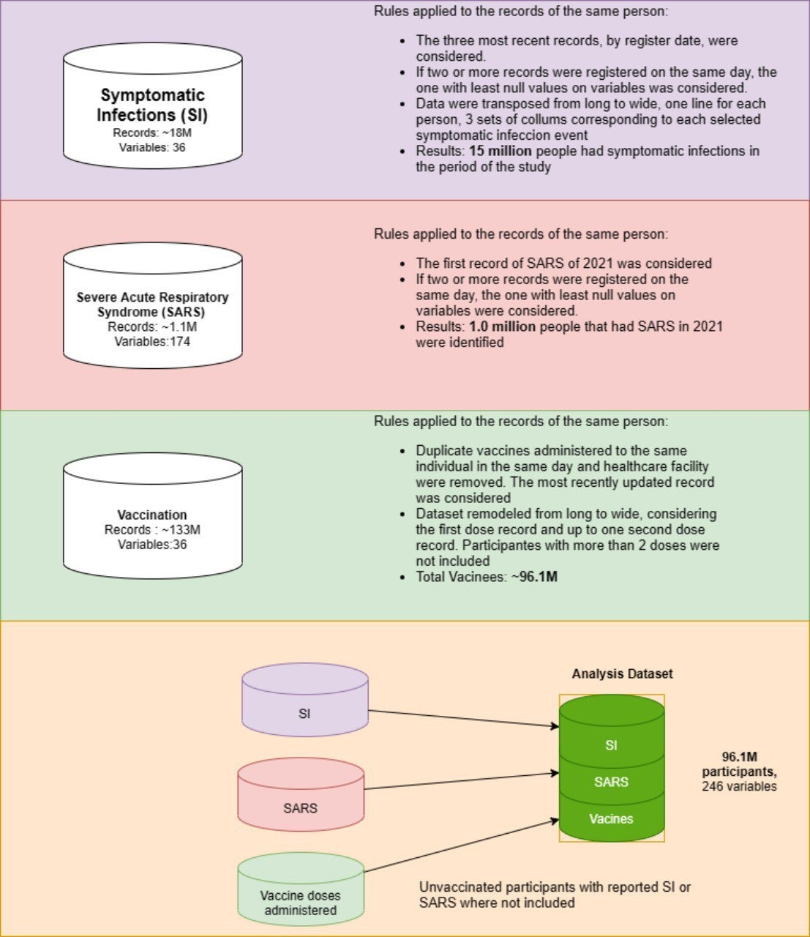
Figure S2. Cumulative incidence of Infection cases after 14 days of second dose. A) Vaxzevria, B) CoronaVac
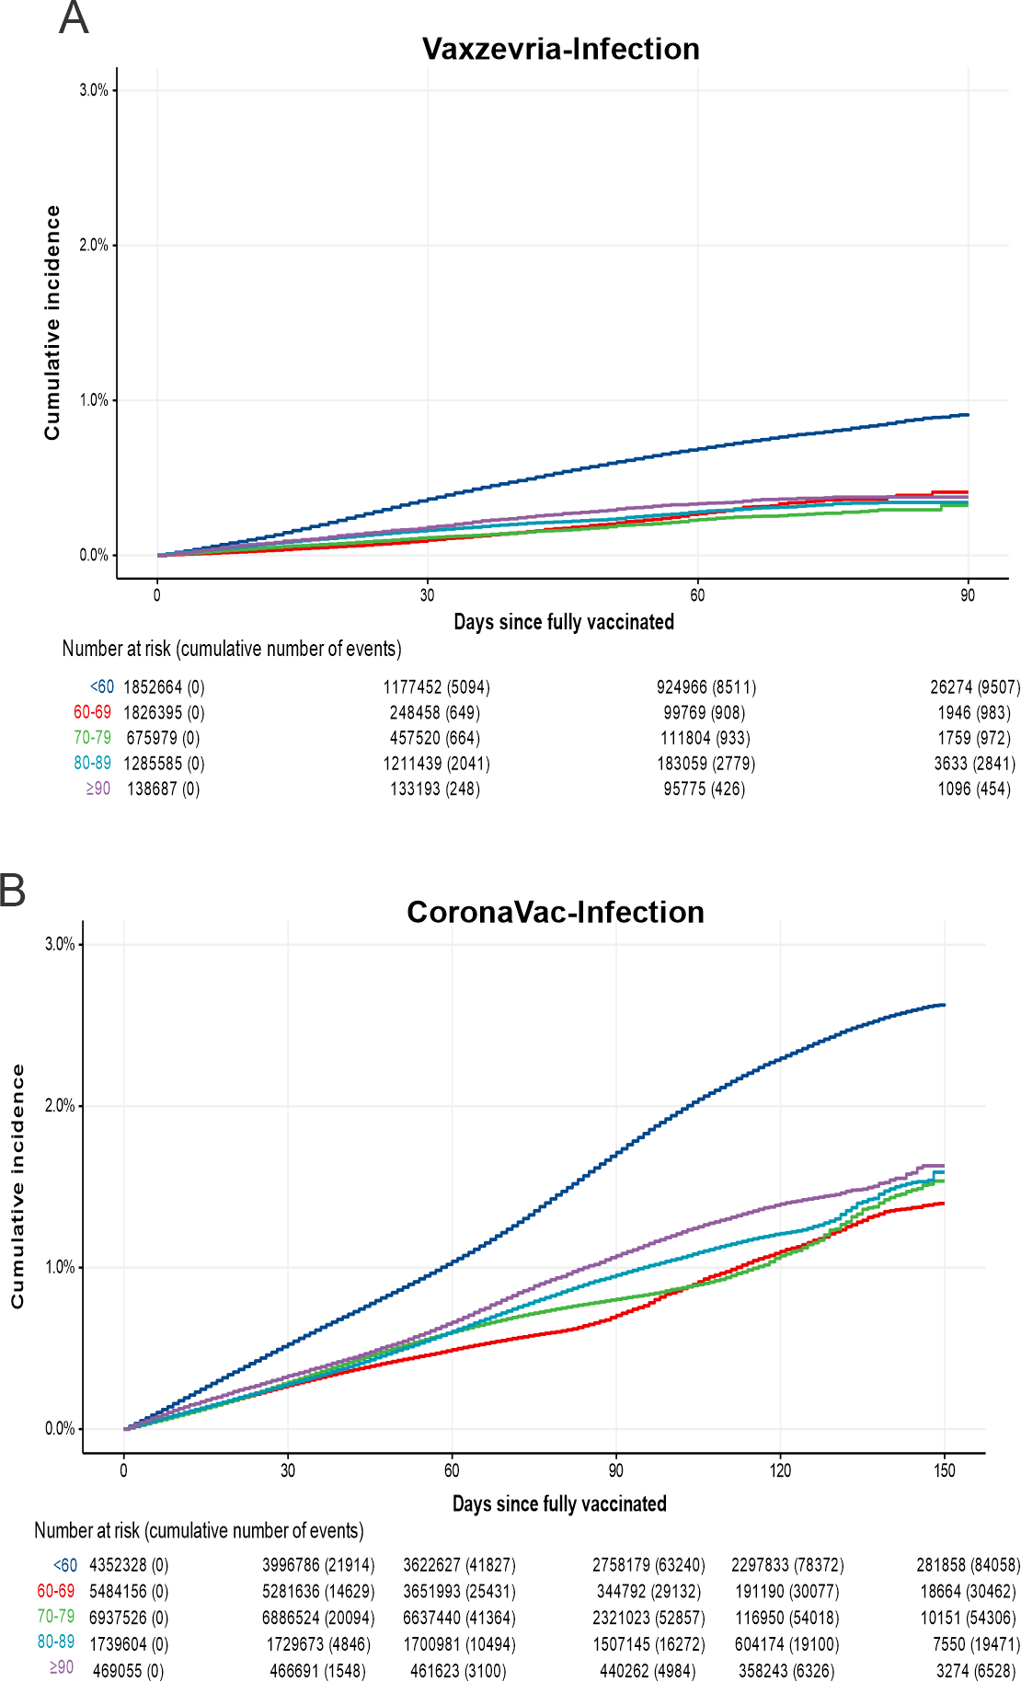

Figure S3. Cumulative incidence of cases requiring ICU admission after 14 days of second dose. A) Vaxzevria, B) CoronaVac
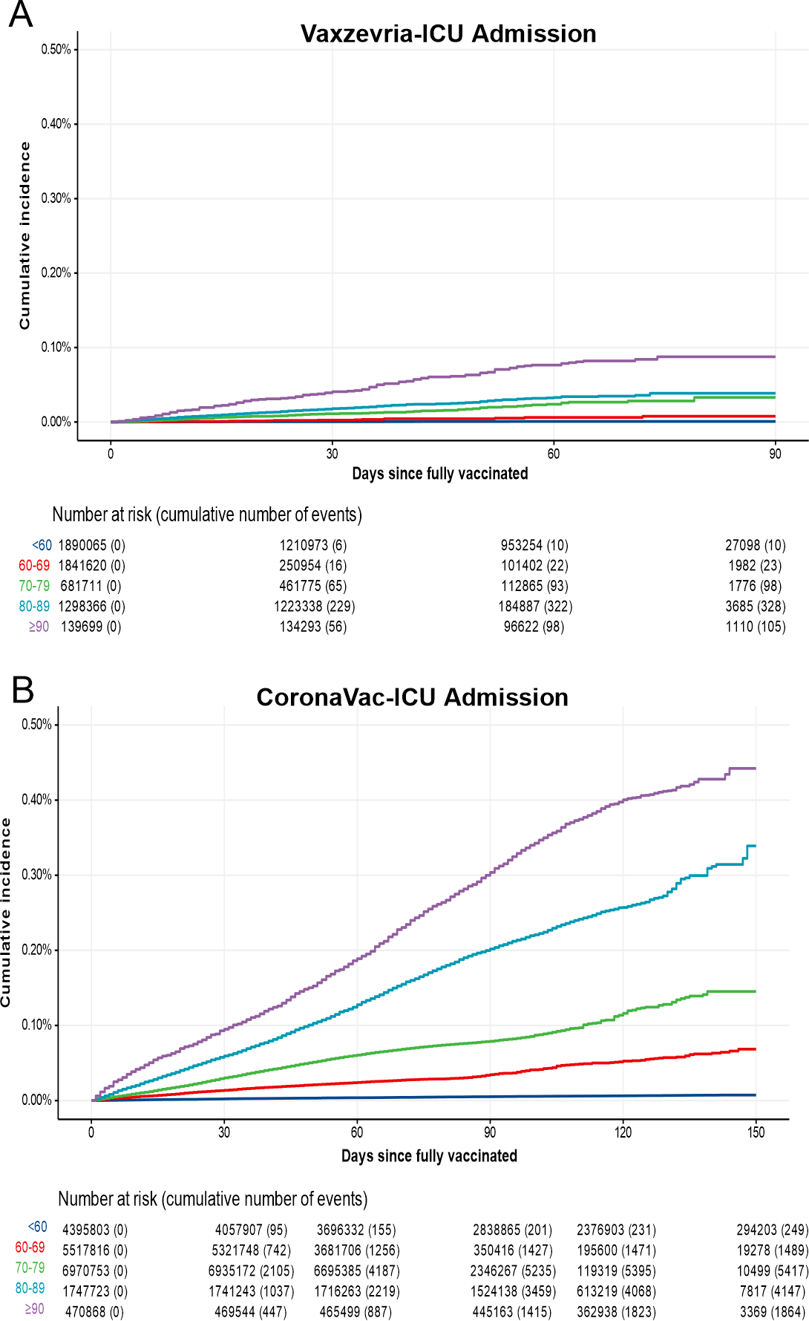

Figure S4. Cumulative incidence of fatal cases after 14 days of second dose. A) Vaxzevria, B) CoronaVac
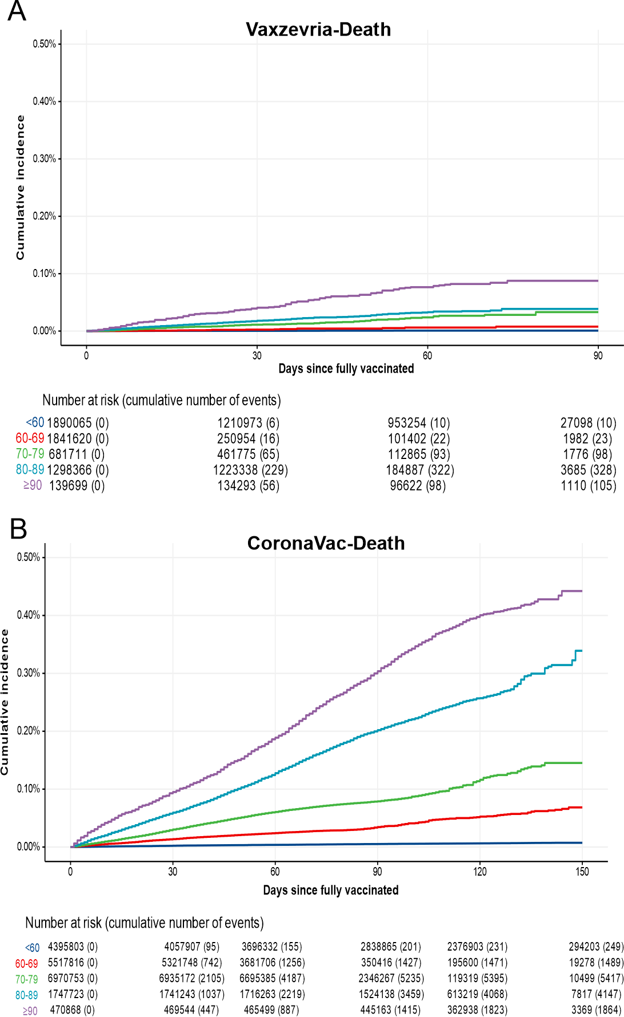

The RECORD statement – checklist of items, extended from the STROBE statement, that should be reported in observational studies using routinely collected health data.

 | Item No. | STROBE items | RECORD items | Location in manuscript where items are reported
Title and abstract
 | 1 | (a) Indicate the study’s design with a commonly used term in the title or the abstract (b) Provide in the abstract an informative and balanced summary of what was done and what was found | RECORD 1.1: The type of data used should be specified in the title or abstract. When possible, the name of the databases used should be included.  RECORD 1.2: If applicable, the geographic region and timeframe within which the study took place should be reported in the title or abstract.  RECORD 1.3: If linkage between databases was conducted for the study, this should be clearly stated in the title or abstract. | 1.1. Databases described in Methods in the Abstract  1.2. Time and region described in the Abstract  1.3. Linkage of databases pointed in the abstract
Introduction
Background rationale | 2 | Explain the scientific  background and rationale for the investigation being reported |  | Background and Research in context
Objectives | 3 | State specific objectives, including any prespecified hypotheses |  | Last paragraph Background session
Methods
Study Design | 4 | Present key elements of study design early in the paper |  | Abstract and Methods session
Setting | 5 | Describe the setting, locations, and relevant dates, including periods of recruitment, exposure, follow-up, and data collection |  | Abstract and Methods session

Participants | 6 | - Cohort study - Give the eligibility criteria, and the sources and methods of selection of participants. Describe methods of follow-up  Case-control study - Give the eligibility criteria, and the sources and methods of case ascertainment and control selection. Give the rationale for the choice of cases and controls Cross-sectional study - Give the eligibility criteria, and the sources and methods of selection of participants  - Cohort study - For matched studies, give matching criteria and number of exposed and unexposed  Case-control study - For matched studies, give matching criteria and the number of controls per case | RECORD 6.1: The methods of study population selection (such as codes or algorithms used to identify subjects) should be listed in detail. If this is not possible, an explanation should be provided.  RECORD 6.2: Any validation studies of the codes or algorithms used to select the population should be referenced. If validation was conducted for this study and not published elsewhere, detailed methods and results should be provided.  RECORD 6.3: If the study involved linkage of databases, consider use of a flow diagram or other graphical display to demonstrate the data linkage process, including the number of individuals with linked data at each stage. | 6.1 – Study design and datasets, in Methods  6.2. The whole population of vaccines in Brazil was enrolled and exclusion criteria are indicated in Methods.  6.3. Supplementary Figure S1
Variables | 7 | Clearly define all outcomes, exposures, predictors, potential confounders, and effect modifiers. Give diagnostic criteria, if applicable. | RECORD 7.1: A complete list of codes and algorithms used to classify exposures, outcomes, confounders, and effect modifiers should be provided. If these cannot be reported, an explanation should be provided. | Vigivac.fiocruz.br
Data sources/ measurement | 8 | For each variable of interest, give sources of data and details of methods of assessment (measurement).  Describe comparability of assessment methods if there is  more than one group |  | Exposures and Outcomes Section

Bias | 9 | Describe any efforts to address potential sources of bias |  | Adressed in Discussion Section
Study size | 10 | Explain how the study size was arrived at |  | The study started with the whole population of vaccinees and this is indicated in Study Design and Datasets
Quantitative variables | 11 | Explain how quantitative variables were handled in the analyses. If applicable, describe which groupings were chosen,  and why |  | Described in Statistical analyses section
Statistical methods | 12 | (a) Describe all statistical methods, including those used to control for confounding (b) Describe any methods used to examine subgroups and interactions  - Explain how missing data were addressed  - Cohort study - If applicable, explain how loss to follow-up was addressed  Case-control study - If applicable, explain how matching of cases and controls was addressed  Cross-sectional study - If applicable, describe analytical methods taking account of sampling strategy  - Describe any sensitivity analyses |  | (a) Described in Statistical analyses section  (b) Described in Exposure and outcomes and in the Statistical analyses section  (c) Described at the end of Statistical Analyses section  (d) Not applicable to the study design  (e) Described in the Statistical analyses section
Data access and cleaning methods |  | .. | RECORD 12.1: Authors should describe the extent to which the investigators had access to the database population used to create the study population. | Described in Dataset section

 |  |  | RECORD 12.2: Authors should provide information on the data cleaning methods used in the study. | Flowcharts (Linkage and Study)
Linkage |  | .. | RECORD 12.3: State whether the study included person-level,  institutional-level, or other data linkage across two or more databases. The methods of linkage and methods of linkage quality evaluation should be provided. | Linkage Flowchart provided in supplementary documents
Participants | 13 | - Report the numbers of individuals at each stage of the study (e.g., numbers potentially eligible, examined for eligibility, confirmed eligible, included in the study, completing follow-up, and analysed)  - Give reasons for nonparticipation at each stage. (c) Consider use of a flow diagram | RECORD 13.1: Describe in detail the selection of the persons included in the study (i.e., study population selection) including filtering based on data quality, data availability and linkage. The selection of included persons can be described in the text and/or by means of the study flow diagram. | Flowcharts are provided for the Linkage and Study population selection
Descriptive data | 14 | - Give characteristics of study participants (e.g., demographic, clinical, social) and information on exposures and potential confounders  - Indicate the number of participants with missing data for each variable of interest (c) Cohort study - summarise follow-up time (e.g., average and total amount) |  | In the Results section
Outcome data | 15 | Cohort study - Report numbers of outcome events or summary measures over time  Case-control study - Report numbers in each exposure |  | Sup Table S1

category, or summary measures of exposure
Cross-sectional study - Report numbers of outcome events or summary measures
Main results | 16 | (a) Give unadjusted estimates and, if applicable, confounderadjusted estimates and their precision (e.g., 95% confidence interval). Make clear which confounders were adjusted for and why they were included (b) Report category boundaries when continuous variables were categorized  (c) If relevant, consider translating estimates of relative risk into absolute risk for a meaningful time period |  | Table 1
Other analyses | 17 | Report other analyses done—  e.g., analyses of subgroups and interactions, and sensitivity analyses
Key results | 18 | Summarise key results with reference to study objectives |  | Summarised both in abstracts and results
Limitations | 19 | Discuss limitations of the study, taking into account sources of potential bias or imprecision. Discuss both direction and magnitude of any potential bias | RECORD 19.1: Discuss the  implications of using data that were not created or collected to answer the specific research question(s). Include discussion of misclassification bias, unmeasured confounding, missing data, and changing eligibility over time, as they pertain to the study being reported. | In discussion section
Interpretation | 20 | Give a cautious overall interpretation of results considering objectives, |  | Discussion
 |  | limitations, multiplicity of analyses, results from similar studies, and other relevant evidence |  | Discussion
Generalisability | 21 | Discuss the generalisability (external validity) of the study results |  | Discussion
Funding | 22 | Give the source of funding and the role of the funders for the present study and, if applicable, for the original study on which the present article is based |  | Declaration of interests and Funding
Accessibility of protocol, raw data, and programming code |  | .. | RECORD 22.1: Authors should provide information on how to access any supplemental information such as the study protocol, raw data, or programming code. | Vigivac.fiocruz.br

*Reference: Benchimol EI, Smeeth L, Guttmann A, Harron K, Moher D, Petersen I, Sørensen HT, von Elm E, Langan SM, the RECORD Working Committee. The REporting of studies Conducted using Observational Routinely-collected health Data (RECORD) Statement. PLoS Medicine 2015; in press.

*Checklist is protected under Creative Commons Attribution (CC BY) license.

